Group 4’s Model Use Case Report

**Use Case Document for ADAV System Final Report**

Authors: Men at Work: Maxwell Polley, Ryan Patton, William Symolon, Joseph Mitchell

Revision: 0.1

May 03, 2020

Revision History

|  |  |  |  |
| --- | --- | --- | --- |
| **Revision** | **Date** | **Description** | **Author** |
| 0.1 | 05/03/2020 | Behavioral Report – Scenario Use Cases | Men at Work – Ryan Patton |

Table of Contents

1. Introduction 4

1.1. Purpose 4

1.2. Scope 4

1.3. Overview 4

2. Scenario Five Use Cases diagram 5

2.1. Description 5

3. Scenario Four Use Cases diagram 6

3.1. Description 6

4. Scenario One Use Cases diagram 7

4.1. Description 7

5. Scenario Seven Use Cases diagram 8

5.1. Description 8

6. Scenario Six Use Cases diagram 9

6.1. Description 9

7. Scenario Three Use Cases diagram 10

7.1. Description 10

8. Scenario Two Use Cases diagram 11

8.1. Description 11

# Introduction

## Purpose

This document provides an overview of the seven operational scenarios high-level use cases breakdown. The sub-use cases are contained within each scenarios use case.

## Scope

The Air Deliverable Amphibious Vehicle (ADAV) advances military personnel capabilities around rivers, estuaries, and littoral environments. The use cases presented within detail the ways in which the ADAV will be used in battlefield scenarios, highlighting the functionality of the system.

## Overview

This document provides the seven operational scenarios derived from the Project Proposal in the context of their functional uses. Each scenario’s use case shows its associated sub-use cases for further breakdown and the flow of the sub-use cases to idealize the flow of operations in each scenario.

# Scenario Five Use Cases diagram



1. - Scenario Five Use Cases diagram

## Description

Details Scenario Five – Foot-Soldier Infiltration

The sub-use cases contained within the scenario use case consist of the following (from top to bottom):

Prepare ADAV

Load onto Vehicle, Transit Inland

Move to Shore While Under Attack

Transit from Water to Land

Perform Operations in Transit

Deploy Soldiers into Combat Zone

Remain on Station

Neutralize Threats

Pick Up Soldiers

Return to Ship for Extraction

# Scenario Four Use Cases diagram



1. - Scenario Four Use Cases diagram

## Description

Details Scenario Four – Foot-Soldier Extraction from Front Line

The sub-use cases contained within the scenario use case consist of the following (from top to bottom):

Prepare ADAV

Load onto Vehicle, Transit Inland

Deploy ADAV

Transit from Water to Land

Transit Inland to Combat Zone

Perform Operations in Transit

Pick Up Soldiers

Return to Ship for Extraction

# Scenario One Use Cases diagram



1. - Scenario One Use Cases diagram

## Description

Details Scenario One – Deployment via C-17

The sub-use cases contained within the scenario use case consist of the following (from top to bottom):

Prepare ADAV

Load onto Vehicle, Transit Inland

<break in flow to separate battlefield operations>

Unload from Transport

Protect Occupants from Enemy

Remain on Station

Neutralize Threats

Return to Ship for Extraction

# Scenario Seven Use Cases diagram

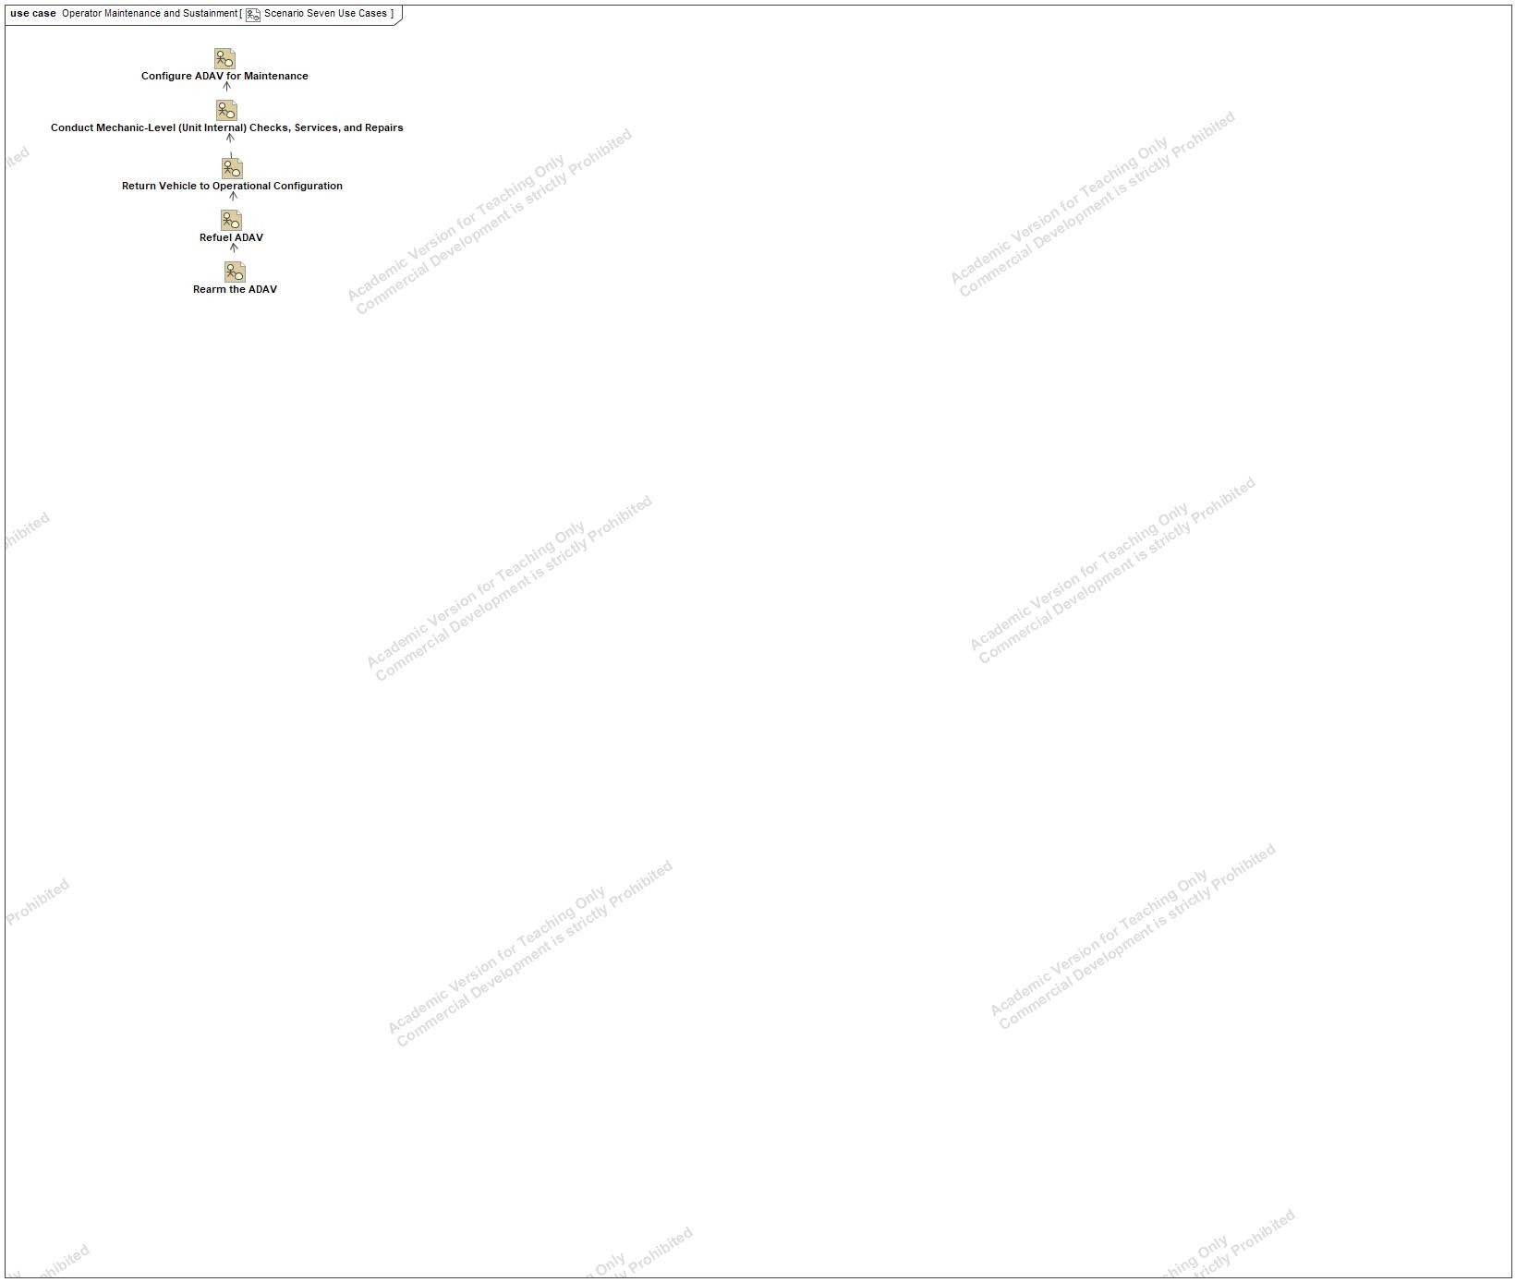

1. - Scenario Seven Use Cases diagram

## Description

Details Scenario Seven – Operator Maintenance and Sustainment

The sub-use cases contained within the scenario use case consist of the following (from top to bottom):

Configure ADAV for Maintenance

Conduct Mechanic-Level (Unit Internal) Checks, Services, and Repairs

Return Vehicle to Operational Configuration

Refuel ADAV

Rearm the ADAV

# Scenario Six Use Cases diagram



1. - Scenario Six Use Cases diagram

## Description

Details Scenario 6 – Training

The sub-use cases contained within the scenario use case consist of the following (from top to bottom):

Prepare ADAV

Load Crew

Transit Inland to Combat Zone

Protect Occupants from Enemy

Remain on Station

Neutralize Threats

Return to Training Start Location

# Scenario Three Use Cases diagram



1. - Scenario Three Use Cases diagram

## Description

Details Scenario Three – Land Deployment via Landing Craft Heavy (LCH)

The sub-use cases contained within the scenario use case consist of the following (from top to bottom):

Prepare ADAV

Load onto Vehicle, Transit Inland

Deploy ADAV

Transit Inland to Combat Zone

Protect Occupants from Enemy

Remain on Station

Neutralize Threats

Return to Ship for Extraction

# Scenario Two Use Cases diagram



1. - Scenario Two Use Cases diagram

## Description

Details Scenario Two – Sea Deployment via RAN Landing Helicopter Deck (LHD)

The sub-use cases contained within the scenario use case consist of the following (from top to bottom):

Prepare ADAV

Load onto Vehicle, Transit Inland

Move to Shore While Under Attack

Transit from Water to Land

Transit Inland to Combat Zone

Protect Occupants from Enemy

Remain on Station

Neutralize Threats

Return to Ship for Extraction